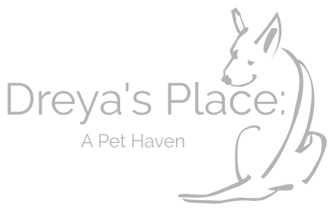

Dreya’s Place: A Pet Haven

Meet and Greet application!

Please email completed application
to dreyasplace@gmail.com

Welcome to Dreya’s Place: A Pet Haven. Dreya’s Place is a 501(c)3, nonprofit, haven for pets whose human guardians have passed away or gone into full time nursing care. While many of the pets who come to Dreya’s Place remain with us as residents, some of them come to us to find their very own homes. (We do occasionally pull from shelters or take in pets n need from other sources as well. We will clarify your particular pet’s story!)

For these pets, we seek the best, most loving homes! Our concern is always for the pet and their well-being. With that in mind, please fill out the following screening application so that we can ensure the most appropriate home and the best match for the pets who have come to us – most of whom are mourning their own loss and depending on us for their future.

Please read carefully and fill out all questions as completely as possible!
Please submit this completed form to dreyasplace@gmail.com and remember to keep a copy for yourself!

Who are you interested to meet? __________________________________________

IN ORDER TO BE CONSIDERED AS AN ADOPTER, YOU MUST:

- Be 21 years of age or older
- Have identification showing your present address
- Have the knowledge and consent of your landlord / HOA, if applicable.
- Be able and willing to spend the time and money necessary to provide training, medical treatment, and proper care for a pet.

Today’s Date: ________________

Name: __________________________________________________________________

Occupation: _____________________ phone: ______________________________

Street Address: ___________________________________________________________

City, State, & Zip: ________________________________________________________

Email address: _________________ __________________________________________

Is this your first experience with a rescue pet? _____Yes _____No

Do you currently have pets in your household? _____ Yes ______ No

What kind and how many? _________________________________________________

Do you live in ______Apartment ______Town Home ______Mobile Home
______ House _____other: ________________________________

How many people live in your household? _____________________________________
Do all adults know that you plan to adopt? _____Yes _____No
If there are any children in the household, what are their ages? _____________________

When would you be available to meet this pet? You will need to drive to Mansfield, TX. Please list several available times / days: ______________________________________

________________________________________________________________________

________________________________________________________________________

Signed: _________________________________________Date:___________________

