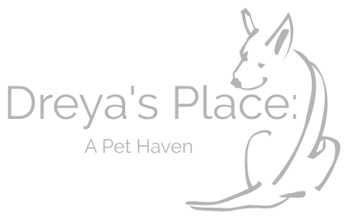

Dreya’s Place: A Pet Haven

Please email completed and signed application
to dreyasplace@gmail.com

Welcome to Dreya’s Place: A Pet Haven. Dreya’s Place is a 501(c)3, nonprofit, haven for pets whose human guardians have passed away or gone into full time nursing care. While many of the pets who come to Dreya’s Place remain with us as residents, some of them come to us to find their very own homes.

For these pets, we seek the best, most loving homes! Our first concern is always for the pet and their well-being. With that in mind, please fill out the following application so that we can ensure the most appropriate home and the best match for the pets who have come to us – mourning their own loss and depending on us for their future.

Please read carefully and fill out all questions as completely as possible!
Please submit this completed form to dreyasplace@gmail.com and remember to keep a copy for yourself!

THIS IS AN APPLICATION TO FOSTER A PET FOR DREYA’S PLACE

We will check references and complete a home visit where all members of the family need to present (including pets).

IN ORDER TO BE CONSIDERED AS A FOSTER, YOU MUST:

- Be 21 years of age or older
- Have identification showing your present address
- Have the knowledge and consent of your landlord or HOA, if applicable.
- Be able and willing to spend the time necessary to provide training, medical treatment, and proper care for a pet.

Date: ________________

Name: _________________________________________________________________

Occupation: _____________________________________________________________

Street Address: ___________________________________________________________

City, State, & Zip: ________________________________________________________

Cell phone: _______________________ e-mail address: _________________________

Dreya’s Place: A Pet Haven. reserves the right to refuse adoption or foster to anyone. No animals will be entrusted to prospective fosters who mislead or fail to provide accurate information on the adoption survey/application.

You have expressed interest in fostering: ___ ___________________________

Is this your first experience with a rescue pet? _____Yes _____No

What pets do you currently have in your household?
Type Spay/Neutered Kept Where? Age
Dog/Cat Yes/No In/Out

Name: _______________ _________ ____________ __________ _______
Name: _______________ _________ ____________ __________ _______
Name: _______________ _________ ____________ __________ _______

Do your current pets get along with other animals? ______________________________

Are you currently fostering for another rescue or shelter? (who?)
_______________________________________________________________________

*REFERENCES* (name, phone number, numbers of years known, and
relationship.)

1._________________________________________________________________

__________________________________________________________________

2.__________________________________________________________________

__________________________________________________________________

Do you live in ______Apartment ______Town Home ______Mobile Home
______ House _____other: ________________________________

Do you currently _______Own or _______Rent your home or ______Live with parents

If you rent, does your lease allow pets? _____Yes _____No

If you rent, what is your landlord’s name? __________________ Phone: _____________

If you own, do you live in an HOA? __________ Are there breed restrictions in your

neighborhood? ( if so, which breeds?__________________________________________

How long have you lived at the above address? _________________________________

How many people live in your household? _____________________________________
Do all adults know that you plan to foster? _____Yes _____No
If there are any children in the household, what are their ages? _____________________

Please read the following statements and sign the application as agreement that you understand their validity as well as the answers above.

- Dreya’s Place: A Pet Haven has the right to deny the foster or adoption of any animal for any reason.
- If you no longer wish to foster the pet, you must return them to Dreya’s Place: A Pet Haven. We will welcome our pets back and would be upset to find out that they were rehomed without our consent.
- Please make time allowances for us to find a new placement for the pet if you need to stop fostering.

Signed: _________________________________________Date:___________________

